Main Author, rest of authors not bold
Title of the abstract in bold 14 points
Department address written in italic
Email in italic
Main text of the abstract should be written with font 12, Arial. No indent of the paragraph. The references should be noted as the following example (Angew. Chem.).^{[1]}
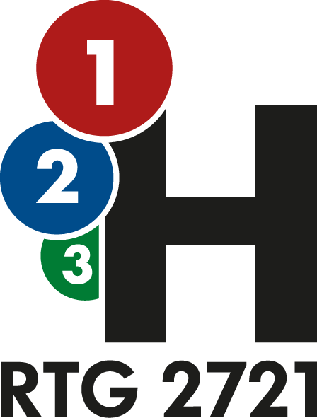
The figures in the abstract are allowed if they fit into one page limit and should be referred to in the text, accordingly, like in figure 1.
Figure 1: Figure captions should be below the figure.
Abstracts are accepted in .pdf formats.
[1] A. Author, B. Author, C. Author, Title of the Journal/Publishing house Year, issue number, Pages.

